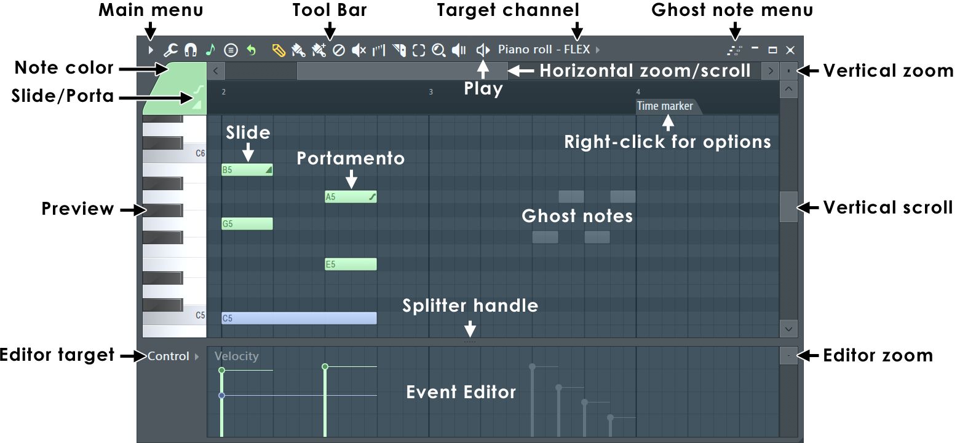
NOTES: You can click the (Middle-Mouse-Button) and drag in the Piano roll to scroll vertically and horizontally at the same time. To change the selected Note Color (Left-click) the color selector. To set a custom color, (Right-click) it.
Piano roll Basics
- Notes - are displayed as horizontal bars. Slides are shown as horizontal bars with a small triangle drawn in the right side.
- Pitch - is mapped from bottom (low) to top (high).
- Duration - The horizontal length represents time. The number on the Piano roll's top-ruler are bars (groups of beats).
- Resolution / grid - The smaller grid each bar is divided into are set by the window's snap () setting. Scroll speed will slow when snap settings other than 'Line' are used. Resolution can also change with Zoom when Snap is set to Line. Selecting Main will use the Global Snap value.
NOTES:
- Click-and-hold - It's functions include:
  - Copy note: Hold on an existing note to copy it.
  - Cycle slide/porta - Click and hold when adding a note to cycle through slide & porta event modes.
  - Glue notes - Place the cursor between 2 neighbor notes, so the resize cursor appears, then click and hold to glue them.
- Mouse-wheel velocity - Hold (Alt) and use Mouse-wheel while hovering notes to change velocity. Alternatively, hover one note in a selection of notes with the same technique.
- Mouse-wheel tools - Change tools by holding right click and rolling the wheel.
- Time Markers - To add make sure you are on the Builder Page and use to add a Time Marker where the Playhead is located. You can then (Right+Click) it to select a type. When set to type Pattern length (Right+Click) the Time Marker to define the length of the currently selected Pattern.
Piano roll Controls
- Toolbar icons - Along the top of the Piano roll window:
 | Main Menu - Includes: Edit, Snap, Select, Group, Scale, Chord, Time Marker and Detach options.
 | Tools menu - Generate chord progression (Alt+P); Articulate (Alt+L); Quantize (Alt+Q); Chop (Alt/Opt+U); Glue (Ctrl+G); Arpeggiate (Alt+A); Strum (Alt+S); Randomize (Alt+R);
 | Piano roll Snap - Snap determines how Notes will move and quantization aligns events relative to the background grid (Hold Alt to temporarily set snap to 'none'). NOTE: There is a Global Snap selector on the Builder Page.
 | Snap to scale - (Left-Click) to activate and deactivate the Snap to scale - Notes are snapped to the selected scale when moved or clicked in or (Right-Click) to open the options menu to select a Root note and Scale plus set Snap incoming MIDI - So your controller Keys also are instantly snapped to the selected scale.
 | Stamp tool - The Chord Tool lets you pick a Chord and automatically draws the correct notes in the Piano roll. You don’t need to know music theory, just select a name and VibeDAW builds it for you according to the selected scale (see Snap to scale above). Choose a chord (precise chord) or scale (random chord chosen from scale) from the menu, then (Left-Click) in the Piano roll and the Chord will be added in the octave range you click in. NOTE: To get out of the Chord or Scale select Edit from the Tool Menu to go back to normal editing.  How it works - The 'Random chord' mode considers the Scale from the Scale setting in the menu, notes within the time interval of the chord, and any existing chords on either side of the location where a Chord is added. The Chord will be inverted automatically so it starts at the closest possible note above the one clicked on. Clicking within the time interval of an existing chord will regenerate that Chord. If no scale is specified, the tool will infer a scale from existing notes – otherwise it will pick one randomly. TIPS: If there are existing non-chord notes (such as high melody or low bass notes), this tool can be used to create a harmony to accompany those notes. Once you have chords set at the time positions you want, try stamping over the existing ones a few times until you get a progression you like.
 | Draw (P) - (Left-click) to add a note. (Left-click-and-drag) to reposition the note before releasing it. (Right-Click) to delete notes. (Right-Click and drag) to delete multiple notes.
 | Paint (B) - Paints multiple notes as you drag in lines. You can paint notes above or below existing notes to create chords. Left-click to add a single note. Click-and-drag to add multiple notes. Right-Click notes to delete them. Modifier keys: (Shift) - Monophonic paint allows vertical movement while painting AND replaces existing (or selected) notes to create a monophonic score. Use (Ctrl) to make a selection.
 | Delete (D) - Click or Click-and-drag to delete notes. (Right-Click and hold) on the background to open the slice tool (F10 > General settings > Click and hold functions on). Modifier keys: Hold (Ctrl) to make a selection, then press (Delete).
 | Mute (T) - (Left-click) on notes to mute them. (Left-Click and drag) to mute multiple notes. (Right-Click) to delete notes. Modifier keys: (Ctrl) to make a selection.
 | Slice (C) - (Left-click) and drag vertically to slice through notes. Glue notes by making a selection of touching notes and using the (Ctrl+G) shortcut. Modifier keys: (Shift) slice without dragging. (Ctrl) to make a selection. (Shift+Alt) Slice without dragging and with snap set to 'none'.
 | Select (E) - Click notes or Click and drag to make group selections. Modifier keys: (Shift) add to or remove notes from the selection.
 | Zoom to selection (Z) - (Left-Click and drag) to zoom to selection. (Left-click on background) to zoom out. When in other modes use (Ctrl+Right-Click) and drag to make a zoom-to selection. (Right-Click) again to swap between zoom and unzoomed modes. (Right-Click) the icon to open a menu of quick zoom options:  - Zoom in/ Zoom out (Page up / Page down) - Zoom centers on the Cursor position.  - Quick-zoom 1, 2 & 3 (Shift+1, 2, 3) - Three handy zoom levels.  - Zoom out far (Shift+4) - Minimum horizontal zoom.  - On Selection (Shift+5) - Zoom to time-line selection. The command will be disabled if no time region is selected in the timeline.
 | Play / Pause - Left-click play button on header to begin playback. Left-click (while playing) stop button on header to stop and return to the last set start position. NOTE: Spacebar will also start and stop play
- Event editor target - Selects the data to be displayed in the integrated event editor. This can include parameters such as note properties (Panning, Velocity, etc.) or automation events.
- Slide & Portamento - These are flags that can be set per-note and work as follows:
  - Portamento Toggle ( O) - When selected, notes added to the Piano roll will display a 'portamento flag' ( icon). The portamento flag causes a short slide in pitch from the end of one note to the note with the portamento flag. This is a note transition effect. NOTES: 1. these features only work with native VibeDAW instruments and not VST instruments. 2. Click-and-hold functions in piano roll - Click and hold when adding a note to cycle through slide, portamento note mode. See General Options settings.
  - Slide Toggle ( S) - When selected, notes added to the Piano roll become 'slide notes' displaying the slide icon () that causes notes, above or below the slide-note, to slide to the pitch of the slide-note. The slide-time is set by the length of the slide-note.
- Preview keyboard - Click on the keyboard to preview notes. This does not work when play is active.
- Horizontal & Vertical Zoom controls - To horizontally zoom the Piano roll click on the edge of the horizontal position slider and drag. For the vertical zoom boxes likewise click and drag.
- Ghost notes - These are notes in other Piano rolls associated with the current Pattern displayed as notes in the background of the grid so the user can more easily know where notes are already hitting.
- Event Editor - Edit: Note Velocity, Pan, Pitch, Filter cutoff & Automation events (area below the piano roll).
- Notes - Click/select to drag, stretch, paint, clone, copy, etc. (see 'operating with notes' below).
- Splitter handle - Left-click and drag the divider to resize the upper and lower windows. Right-Click to return to the original position.
Using the Piano roll
NOTE: Many of the movement and draw commands are constrained by the snap setting  that controls how notes move relative to the Piano roll grid. Hold the (Alt) key to temporarily bypass snap.
- Tools Menu - () is a shortcut to the Piano roll tools submenu (see the Piano roll menu page, ), containing various commands for operating on patterns in the Playlist.
- Adding Notes - draw mode () allows you to draw, edit and delete notes. To add notes and draw the length, hold the (Left-Shift) Left-click and drag to the desired length. The paint mode () is similar, but allows you to draw multiple notes at once while dragging horizontally in the Piano roll. Notes are added monophonically (replacing any notes they overlap). Hold (Shift) to bypass monophonic paint mode. In draw or paint mode, Left-click in the Piano roll's grid to draw a note. The default length for notes will be equal to the last touched note.
- Deleting notes - Right-Click a note to erase it.
- Selecting/Deselecting groups of notes - There are a number of methods to select several notes, so you can move and resize them all at once:
  - Standard selection - Press and hold (Ctrl key) and either click a note to select it, or drag a rectangle to select all notes in enclosed area.
  - Add notes to selection - Hold (Ctrl+Shift) together while selecting to add notes to the existing selection.
  - Deselect all notes - While holding (Ctrl key), click empty space in Piano roll's grid.
  - Remove notes from selection - (Ctrl+Shift) deselects individual notes from the existing selection of notes.
  - Invert selection - Use (Shift+I).
  - Select mode button - Instead of holding (Ctrl key), you can also switch Piano roll to select mode by clicking the select mode button ().
- Group notes - (Shift+G) to group and (Shift+Alt+G) to ungroup - Group the selected notes. Grouping functions so that an action on any note in the Group will affect all other notes in the same way. Any number of groupings may be created. To group notes: make a selection using the  Select tool, then use the Group function. To remove group notes: make a selection using the  Select tool, then use the ungroup function.
- Copy & Paste - Make a selection (see above), hold the (Shift) button THEN drag selection with the left-mouse button OR (Ctrl+C), scroll to the new position/pattern and (Ctrl+V).
- Duplicate selection - Make a selection and press (Ctrl+B). The selection, or all notes if nothing is selected, will be duplicated to the right of the original selection. To define a specific repeat interval, make a time-line equal to the complete interval to be duplicated and press (Ctrl+B). NOTE: The time-line selection and note selection can be made independently. The repeat interval is set by the time-line selection, the notes duplicated by the note selection. In this way, notes outside the time-line selection can be duplicated according to the time-line interval.
- Moving & resizing notes - Select the note/sequence, Left-click on the note and drag vertically or horizontally. When resizing notes, this is generally done from the note end, the cursor will change to a double-headed arrow when you can click and drag to resize. Some tips...
  - Snap setting  - This will affect horizontal the movement, causing notes to jump between snap locations. Hold (Alt) to override the snap settings for free movement or set snap to 'none'.
  - Change note length/s - You can change the length of single notes or selections of notes. NOTE: The snap setting  will affect the way in which the note changes length.
    - Resizing notes from the end - Move the cursor to the right edge of the note and when the cursor changes to a double-headed arrow (Left-Click) and drag horizontally.
  - Horizontal & vertical lock - Often when moving notes you want to preserve their vertical position (pitch) or horizontal position (timing) location/s:
    - Vertical position lock (pitch) (Shift) - NOTE: First click the note or selection THEN hold (Shift) and drag horizontally.
    - Horizontal position lock (timing) (Ctrl) - NOTE: First click the note or selection THEN hold (Ctrl) and drag vertically.
  - Nudging notes & selections - This allows you to move the note/s by either 'snap' or 'pixel' based units. Snap units: Select the sequence/note and hold the ( Shift key) and use the arrow keys on your keyboard. The snap setting  will affect the bump size. Pixel units: Hold the (Alt) key and use the arrow keys on your keyboard. In this case the zoom setting will affect the bump size.
  - Mouse Wheel - Horizontal note positions can be adjusted by (Shift+Alt+Mouse-Wheel) by holding the cursor over a target note/selection in the Piano roll.
- Stretch / compress scores - Select a group of notes and drag the pop-up handle OR hold (Right-Shift) and drag the right edge of a note in the selection. This changes both note length and sequence duration. (Alt + Right-Shift) will stretch in 25% increments.
- Slice Tool - () allows you to split one or more notes in the direction of the cut through the Piano roll. To use the cut tool, make sure you're in cut mode (the Cut button is selected), Left-click in the grid area and drag to define the "cut line" direction and length. Release the mouse button to split all notes at their intersection point with the cut line.
- Resize chords & splits - Hold (Left-Shift) click and drag on the slice point or right-side of the chord.
- Note properties - Note velocity, panning, filter-cutoff, etc, are available from the Target control menu and appear in the Piano roll Event Editor below the piano roll. Note properties can be adjusted by mouse-wheel (Alt+mouse-wheel) by holding the cursor over a target note in the 'Note event window'.
- Click-and-hold functions in piano roll - Copy: Hold on an existing note. Slide & Porta: Click and hold when adding a note to cycle through slide, portamento event mode.
Selection Stretch Handle
After making a selection the Stretch Handle appears. You can click and drag this to stretch the selected notes. Hold the (Alt) key to apply snap settings. Alternatively, hold (Right-Shift) key then click on the right-side of a note in the group and drag.
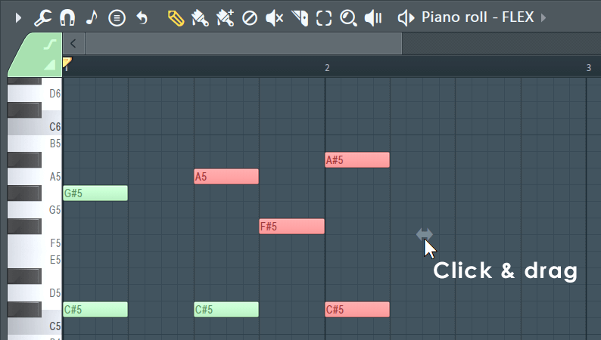
Mouse-wheel Property Note Changes
Hold your mouse over the note and hold (Alt+Mouse-wheel) to change the currently selected note property. To see the property being adjusted maximize the vertical zoom. To fine-tune, hold (Ctrl+Alt+Mouse-wheel)
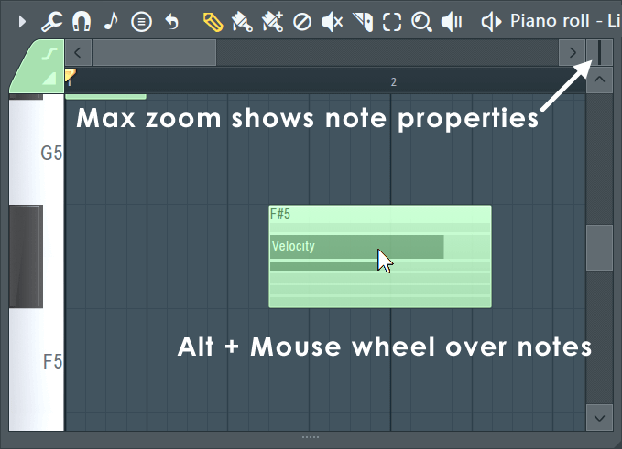
Note Properties & Event Editor
The note properties editor gives you access to a number of per-note properties and event data velocity, pan, release (where supported), Mod X & Y (where supported), pitch etc. Select the data to be edited with the Target control, as shown below.
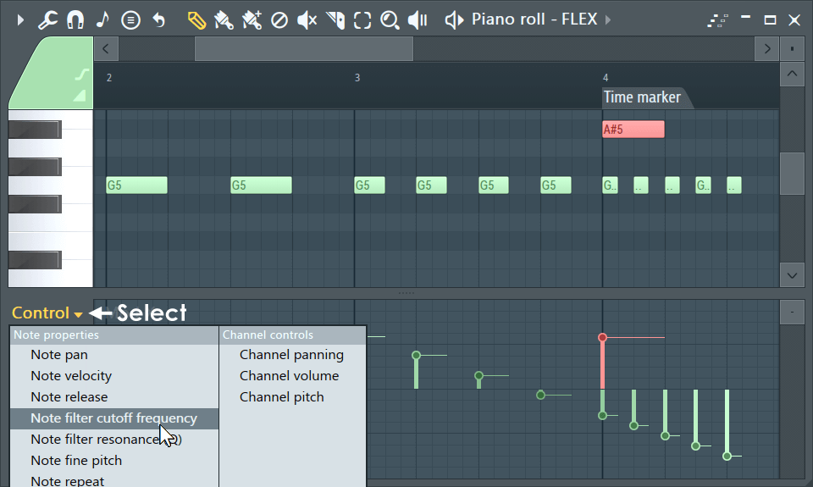
- Selecting Targets - Left-click to select from the menu. You can also roll your (mouse-wheel) while hovering over the selector or (Shift+F) to cycle through them at any time with the Piano roll selected.
- Note properties - are displayed as vertical lines with a small circle at the top. The right-facing tail allows you to see the independent values of notes with the same start time. Note properties move with the notes they belong to. The editor can also display standard Event Automation associated with the pattern. To edit the properties of a note when it has the same start time as others, make a selection first, then edit the property for the note (as shown above in red). To set each note's property to the same value, use (Shift+Left-Click) and drag across the area that should be affected. To reset a property, use (Alt+Left-Click).
Ghost Notes
Ghost Notes show note data from other Channels (Piano rolls). They are a great help when creating melodies and rhythms as you can make edits relative to these notes. There are two types of Ghost Notes - Those within the same Pattern (Solid blocks) and those from other Patterns (Open Blocks). See below to learn more about them...
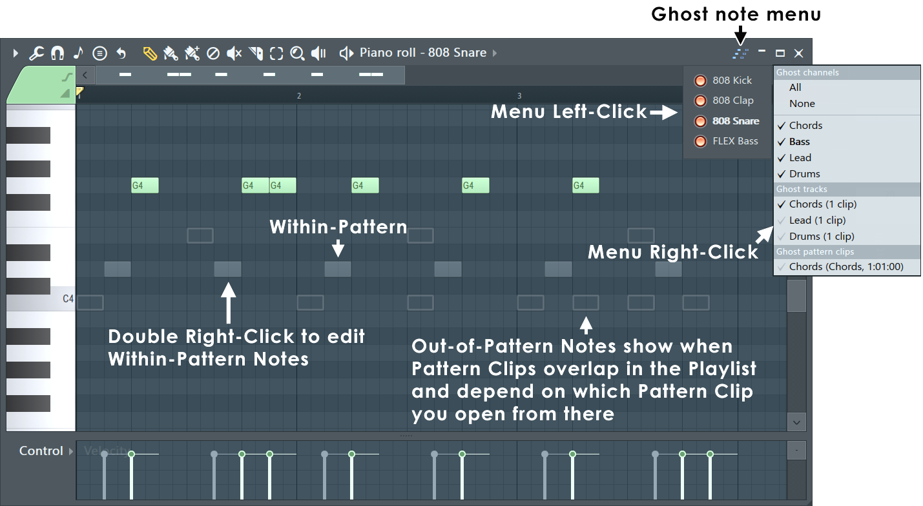
NOTE: When working with overlapping Patterns in the Piano Roll, it matters which page you open to edit the Piano roll. This is how VibeDAW will determine which Patterns are above or below the one you are working on, with the pages piano roll you are on showing above and all other pages piano rolls showing the ghost notes below.
- Ghost Note types:
  - Within Pattern Ghost Notes (Solid blocks)
  - Out of Pattern Ghost Notes (Open blocks)
Scales & Keys (Key Signatures)
While there are always exceptions to this rule, if you use notes within a Key Signature your melodies and, to a slightly lesser extent, chords will sound more harmonious (i.e. better). That's why Snap to scale is such a powerful tool for composing, particularly if you are new to music and don't have a good grasp of what Keys and Scales are. Closely related to Snap to Scale is the Chord Progression Tool, check it out after reading this section. Let's dig a little deeper into this topic ...
In Western music, there are seven 'natural' notes named — A, B, C, D, E, F and G. These are the white notes on a Piano keyboard. By adding 'sharp' or 'flat' versions of these notes, filling in semi-tone or 'half step' intervals, the total number of notes rises to 12. These are the black notes on a Piano keyboard. From these 12 notes almost all Western music is made. The notes can be arranged into scales, where the starting, or tonic note, is repeated at the beginning and end of the scale. More specifically, the important fact is, scales are just pre-defined sequences of note-to-note pitch intervals, with the scale named after its tonic (starting) note. It is the relationship between notes, their pitch intervals that defines the scale, not the note names. This is why you can play the same scale starting on any note, by following a pattern of semitone intervals from note-to-note. There are two very common scales - Major and Minor.
All ascending Major scales have the following sequence of pitch intervals from one note to the next - Tone (200 cents), Tone (200 cents), Semitone (100 cents), Tone (200 cents), Tone (200 cents), Tone (200 cents), Semitone (100 cents). This allows you to start on any note and create a Major scale by following this sequence of note pitch 'intervals'. The result is, all Major scales have a similar sound or melody regardless of the note you start on. If you check the 'Scale' list shown in the Scale menu below, these are just different sequences of intervals between notes (and yes, there are a lot with odd sounding names). Importantly, by using notes only from within a given scale, you can achieve harmonious sounds, making scales the essential basis for creating melodies (sequences of note intervals) and chords (simultaneous note intervals).
The most common scales used in music are the Major (Ionian) and Minor (Aeolian) scales. Starting at the tonic note, the first difference is the pitch interval between the first and third notes of the scales. In a Major scale this pitch interval is a Major third, four semitones. In a Minor scale, the interval is a Minor third, three semitones. The 'third' here refers to the 3rd note in the scale. Generally people agree, the Major third in Major scales creates a brighter, more positive sound. The Minor third in Minor scales has a darker, more somber sound. So scales are emotional and that is why they discussed so much in music composition because music is about feelings. Particularly Jazz which creates feelings of confusion and anger. Confusion when you first hear it, like trying to solve an intractable puzzle. Anger when you have to listen to those who claim superiority because they understand it.
TLDR:
The Key or notes you should use, are defined by two things - Tonic (starting note) and Scale (note intervals sequence). For example 'C Major (Ionian)' or 'G# Major (Ionian)'. The letter is an indicator you should generally start and end your melodies and bass lines, on or near this tonic note, as this will reinforce the Key. The scale sets the note-to-note intervals that are harmonious. If you set Snap to scale on, then you didn't need to read any of the four paragraphs above! Just start clicking around and enter notes that sound good to you.
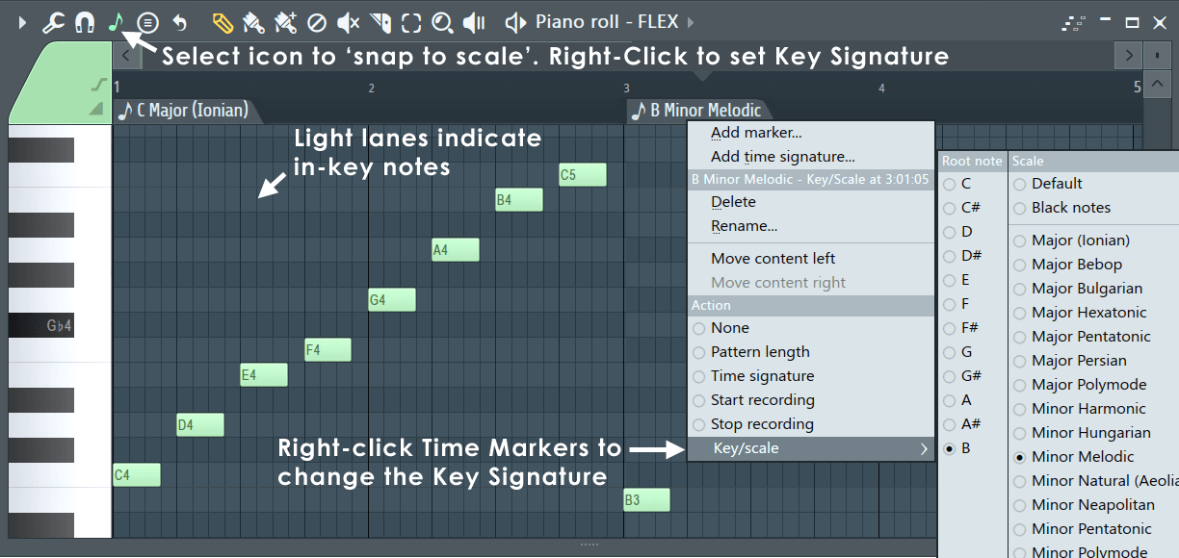
NOTES: The Piano keyboard is designed around the C Major Scale. If you start on C and play only the white notes (up or down) you will play the C Major scale. On other words, the white note intervals are pre-set for C Major. When you combine a Tonic (starting note) and Scale this defines a Key for the music (a 'Key Signature' is printed at the start of all music scores), that sets the harmonic and so emotional tone of the music. Of course, sometimes playing notes out-of scale is also cool.
TIP: (Right-click) the Snap to scale (note icon) and select either the Major (Ionian) or Minor (Aeolian) scale. Then start your melody or bass-line using a note from the first chord in your chord progression. Scales, Keys and Chords are the building blocks of popular music.
Settings
- Note (icon) - From the Piano roll Toolbar:
  - Snap to scale (Left-Click) - When selected, dragged notes will snap to the Scale and Key (highlighted lanes in the Piano roll). NOTE: Notes won't automatically snap until they are moved, even if they fall out-of-scale after settings are changed.
  - Select a scale (Right-Click) - Choose a Tonic, or first note, (left side) and Scale (right side) on the Menu. NOTE: When a scale is selected the background grid of the Piano roll with show notes of that scale highlighted in a lighter color. A Key Signature includes a Tonic note and Scale. Right-Click the Menu to change settings without closing it.

